

DELHI SKILL AND ENTERPRENEURSHIP UNIVERSITY

SESSION 2021-22
SUBJECT:-
Programming in C



PRACTICAL FILE

COURSE :- BCA
ROLL NO :- 41221139
SUBMITTED BY :- SUBMITTED TO:-
Sachin Rajbhar KOMAL Ma’am
INDEX
S.NO | T O P I C S | Date | Teachers  Sign.
1 | To study flowchart, algorithm and pseudocode. | 15/12/21
2 | Write algorithm, flowchart and pseudocode to determine area and perimeter of a circular plot. | 15/12/21
3 | Write algorithm, flowchart and pseudocode to swap two numbers using third variable. | 15/12/21
4 | Write algorithm, flowchart and pseudocode to swap two numbers without using third  variable. | 15/12/21
5 | Write algorithm, flowchart and pseudocode to determine largest of three numbers. | 15/12/21
6 | Write algorithm, flowchart and pseudocode for a simple calculator with the following  operations  ‘+’ - Addition of two numbers  ‘-’ - Subtraction of two numbers  ‘*’ - Multiplication of two numbers  ‘/’ - Division (Quotient)  ‘%’ - Remainder without modulus operation (Dividend = Divisor × Quotient +  Remainder) | 22/12/21
7 | Write algorithm, flowchart and pseudocode to determine sum of digits of a number  (use Do While Loop) | 22/12/21
8 | Write algorithm, flowchart and pseudocode to check whether a number is palindrome | 22/12/21
9 | Write algorithm, flowchart and pseudocode to check whether a number is armstrong  number or not. (Use Do While Loop) | 22/12/21
10 | Write algorithm, flowchart and pseudocode to obtain sum of even numbers between 1  and 100. (Use For Loop - Include both 1 and 100). | 22/12/21
11 | Write a program to input a character and print its ASCII value. | 29/12/21
12 | Write a program in C to swap two numbers without using third variable | 29/12/21
13 | Write a program in C to swap two numbers using third variable | 29/12/21
14 | Write a program in C to input name, roll no, marks in three subjects of a student and calculate average, percentage of the student. The marks variable should be float. | 29/12/21
15 | Write a program in C to check if a number is even or odd using conditional operator. | 29/12/21
16 | Write a program in C to demonstrate Arithmetic Operators. | 5/1/22
17 | Write a program in C to demonstrate Relational Operators. | 5/1/22
18 | Write a program in C to demonstrate Logical Operators. | 5/1/22
19 | Write a program in C to determine greatest of three numbers using conditional operator. The numbers are to be taken as input from the user. | 5/1/22
20 | Write a program in C to demonstrate Bitwise Operators. | 12/1/22
21 | Write a program in C to demonstrate increment and decrement operators. Use both prefix and postfix operators. | 12/1/22
22 | Write a program to input cost price, selling price and determine if it is profit or loss. | 12/1/22
23 | Write a program to calculate the income of individual as per the following slab rates.  Note: If income is the range of Rs. 2,00,001 to Rs. 3,00,000 then tax rate is 10% of Rs. 1,00,000 (Rs. 10,000/-) for a slab of Rs. 1,00,001 to 2,00,000/- plus 20% of the amount in excess of Rs. 2,00,000/- . Tax is calculated similarly for the income more than Rs. 3,00,000. | 12/1/22
  Income | Tax Payable
  Up to Rs. 1,00,000/- | Nil
  From Rs. 1,00,001/- to Rs. 2,00,000/- | 10% of excess over Rs. 1,00,000/-
  From Rs. 2,00,001 to Rs. 3,00,000/- | 20% of excess over Rs. 2,00,000/-
  Above Rs. 3,00,000/- | 30% of excess over Rs. 3,00,000/-
24 | Write a program to implement calculator using switch statement., | 19/1/22
25 | Write a program to determine factorial of a number. | 19/1/22
26 | Write a program to print the Fibonacci Series.  - 1 1 2 3 5……  Input the number of terms from user. | 19/1/22
27 | Write a program to print the multiplication table in the following pattern  - 2 3 4 5 6 7 8 9 10  - 4 6 8 10 12 14 16 18 20  10 20 30 40 50 60 70 80 90 100 | 19/1/22
28 | Write a program to print the following patterns  a  a b  a b c  a b c d  a b c d e  ii) * * * * *  * * * *  * * *  * *  * | 19/1/22
29 | Write a user defined function that takes year as parameter, and it prints whether the year is leap year or not. | 26/1/22
30 | Write a user defined function to print reverse of a number. The number should be passed as argument to the function and the function should return the reverse value. | 26/1/22
31 | Write a program to calculate factorial of a number using recursion | 26/1/22
32 | Write a program to determine the n^{th} Fibonacci term in Fibonacci series using recursion. | 2/2/22
33 | Write a program to swap two numbers using call by value parameter passing mechanism. | 2/2/22
34 | Write a program to display the count of times the function is called. | 2/2/22
35 | Write a program to access a variable defined in other file using extern storage class. | 2/2/22
36 | Write a program to determine the largest element of 1-D array. | 9/2/22
37 | Write a program to add and multiply two matrices. Use 2-D array. Take choice from user whether he want to add or multiply the matrices. Display the original matrices and the computed result. | 9/2/22
38 | Write a program to transpose a matrix. Use 2-D array. Display the original matrix and transposed result. | 9/2/22
39 | Write a C program to display the count of vowels and consonants in a string input by user. | 9/2/22
40 | Write a C program to concatenate first name and last name input by user without using string.h built in functions. | 16/2/22
41 | Write a C program using pointers to evaluate the arithmetic expression z = 5* - *p2/ *p1. | 16/2/22
42 | Write a C program to illustrate the concept of Call By reference. | 16/2/22
43 | Write a C program to determine sum of all elements of one-dimensional array using pointers. | 23/2/22
44 | Write a C program to determine average of all elements of two-dimensional array using pointers. | 23/2/22
45 | Write a C program to calculate return the address of ith element of array using the concept of function returning pointers. | 2/3/22
46 | Write a C program to determine the value of sin and function x^2-x+1 using the concept of function pointers. | 2/3/22
47 | Write a C program to dynamically allocate size for array using malloc/calloc. Read the array elements from user. Reallocate the size using realloc. Deallocate the memory allocated using free. | 9/3/22
48 | Write a program to calculate AREA of a square using macro with arguments. | 9/3/22
49 | Write a program to demonstrate compiler control directives for conditional compilation. | 16/3/22
50 | Write a program to demonstrate pointer to structures. | 16/3/22
51 | Write a program to pass structures to functions. | 16/3/22
52 | Write a program to pass pointer to structures to functions. | 23/3/22
53 | Create an enumeration weekday with enumerators as Sun, Mon, Tue, Wed, Thurs, Fri,  Sat. Print the integral value for Thursday. | 23/3/22
54 | Write a program to  a) Open the file  b) Read the file & write to file  c) Close the file | 23/3/22

Experiment 11
Aim: Write a program to input a character and print its ASCII value.
Software used: CodeBlocks
Program:
#include <stdio.h>
#include <stdlib.h>
int main()
{
char x;
printf("Enter a character\n");
scanf("%c",&x);
printf("ASCII value: %d",x);
return 0;
}
Output:
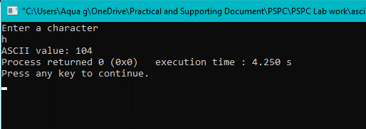

Experiment 12
Aim: Write a program in C to swap two numbers without using third variable
Software used: CodeBlocks
Program:
#include <stdio.h>
//swap two variables without using third variable
int main()
{
int a,b,temp;
printf("Enter two numbers\n");
scanf("%d %d",&a,&b);
a=a+b;
//swap b
b=a-b;
//swap a
a=a-b;
printf("Swapped numbers are\n");
printf("%d %d",a,b);
return 0;
}

Output:
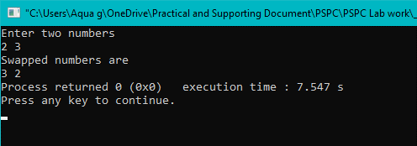

Experiment 13
Aim: Write a program in C to swap two numbers using third variable
Software used: CodeBlocks
Program:
#include <stdio.h>
//swap two variables using third variable
int main()
{
int a,b,temp;
printf("Enter two numbers\n");
scanf("%d %d",&a,&b);
temp=a;
//swap a
a=b;
//swap b
b=temp;
printf("Swapped numbers are\n");
printf("%d %d",a,b);
return 0;
}

Output:
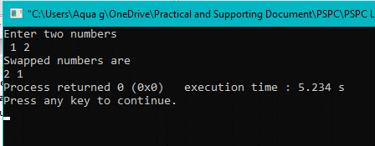

Experiment 14
Aim: Write a program in C to input name, rollno, marks in three subjects of a student and calculate average, percentage of the student. The marks variable should be float.
Software used: CodeBlocks
Program:
#include <stdio.h>
#include <stdlib.h>
int main()
{
int rollno;
float marks1, marks2, marks3, average, percentage;
char name[50];
printf("Enter the name\n");
scanf("%s",name);
printf("Enter the rollno\n");
scanf("%d",&rollno);
printf("Enter the marks in three subjects\n");
scanf("%f %f %f",&marks1,&marks2,&marks3);
// Calculate average
average= (marks1+marks2+marks3)/3;
// Calculate percentage
percentage= (marks1+marks2+marks3)/300*100;
printf("Average = %f\n",average);
printf("Percentage = %f",percentage);
return 0;
}

Output:
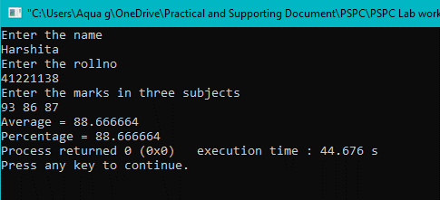

Experiment 15
Aim: Write a program in C to check if a number is even or odd using conditional operator.
Software used: CodeBlocks
Program:
#include <stdio.h>
int main()
{
int num;
printf("Enter the number\n");
scanf("%d",&num);
(num%2==0)?printf("Number is even"):printf("Number is odd");
return 0;
}

Output:
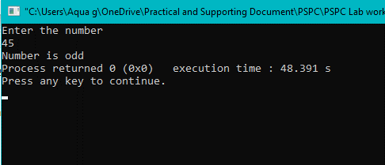

Experiment 16
Aim: Write a program in C to demonstrate Arithmetic Operators.
Software used: CodeBlocks
Program:
#include <stdio.h>
int main()
{
int a,b;
printf("Enter two numbers\n");
scanf("%d %d",&a,&b);
printf("a+b= %d\n",a+b);
printf("a-b= %d\n",a-b);
printf("a*b= %d\n",a*b);
printf("a/b= %d\n",a/b);
printf("a%%b= %d\n",a%b);
return 0;
}
Output:
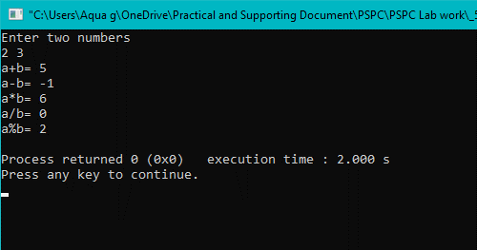

Experiment 17
Aim: Write a program in C to demonstrate Relational Operators.
Software used: CodeBlocks
Program:
#include <stdio.h>
int main()
{
int a,b;
printf("Enter two numbers\n");
scanf("%d %d",&a,&b);
printf("a==b= %d\n",a==b);
printf("a!=b= %d\n",a!=b);
printf("a>b = %d\n",a>b);
printf("a<b = %d\n",a<b);
printf("a>=b= %d\n",a>=b);
printf("a<=b= %d\n",a<=b);
return 0;
}
Output:
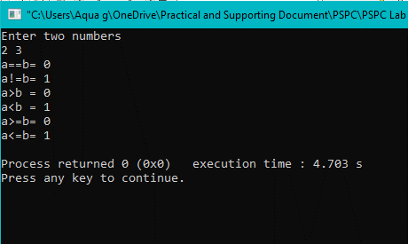

Experiment 18
Aim: Write a program in C to demonstrate Logical Operators.
Software used: CodeBlocks
Program:
#include <stdio.h>
int main()
{
int a,b;
printf("Enter two numbers\n");
scanf("%d %d",&a,&b);
printf("a&&b = %d\n",a&&b);
printf("a||b = %d\n",a||b);
printf("!(a==b)= %d\n",!(a==b));
return 0;
}
Output:
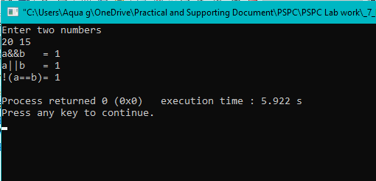

Experiment 19
Aim: Write a program in C to determine greatest of three numbers using conditional operator. The numbers are to be taken as input from the user.
Software used: CodeBlocks
Program:
#include <stdio.h>
#include <stdlib.h>
int main()
{
int a,b,c;
printf("Enter three numbers\n");
scanf("%d %d %d",&a,&b,&c);
printf("Largest number is ");
(a>b)?(a>c)?printf("%d",a):printf("%d",c): (b>c)?printf("%d",b):printf("%d",c);
return 0;
}
Output:
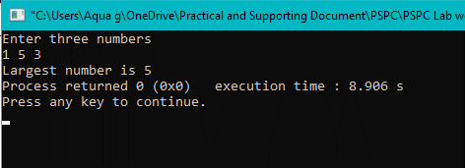

Experiment 20
Aim: Write a program in C to demonstrate Bitwise Operators.
Software used: CodeBlocks
Program:
#include <stdio.h>
#include <stdlib.h>
// &,|,~,<<,>>,^ do bitwise manipulation
int main()
{
int a,b;
printf("Enter two numbers\n");
scanf("%d %d",&a,&b);
printf("a&b = %d\n",a&b);
printf("a|b = %d\n",a|b);
printf("~a ~b = %d %d\n",~a,~b);
printf("a<<b = %d\n",a<<b);
printf("a>>b = %d\n",a>>b);
printf("a^b = %d\n",a^b);
return 0;
}
Output:
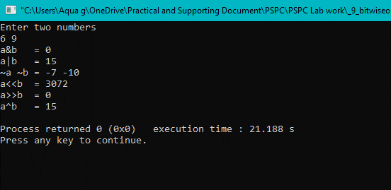

Experiment 21
Aim: Write a program in C to demonstrate increment and decrement operators. Use both prefix and postfix operators.
Software used: CodeBlocks
Program:
#include <stdio.h>
#include <stdlib.h>
/* x++, x--(Postfix)
++x, --x(Prefix) */
int main()
{
int a;
printf("Enter a number\n");
scanf("%d",&a);
printf("Prefix operator\n ++a= %d\n --a= %d\n",++a,--a);
printf("Postfix operator\n a++= %d\n a--= %d\n",a++,a--);
return 0;
}
Output:
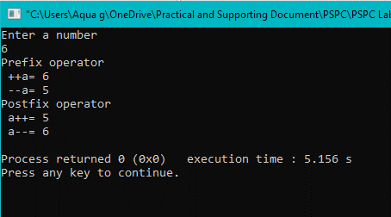

Experiment 22
Aim: Write a program to input cost price, selling price and determine if it is profit or loss.
Software used: CodeBlocks
Program:
#include <stdio.h>
#include <stdlib.h>
int main()
{
int cost, sell;
printf("Enter Cost Price & Selling Price\n");
scanf("%d %d",&cost,&sell);
if(cost<sell)
printf("Congo! Profit");
else
printf("Loss");
return 0;
}
Output:
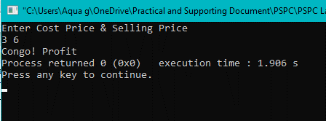

Experiment 23
Aim: Write a program to calculate the income of individual as per the following slab rates
Income | Tax Payable
Upto Rs. 1,00,000/- | Nil
From Rs. 1,00,001/- to Rs. 2,00,000/- | 10% of excess over Rs. 1,00,000/-
From Rs. 2,00,001 to Rs. 3,00,000/- | 20% of excess over Rs. 2,00,000/-
Above Rs. 3,00,000/- | 30% of excess over Rs. 3,00,000/-
Note: If income is the range of Rs. 2,00,001 to Rs. 3,00,000 then tax rate is 10% of Rs. 1,00,000 (Rs. 10,000/-) for a slab of Rs. 1,00,001 to 2,00,000/- plus 20% of the amount in excess of Rs. 2,00,000/- . Tax is calculated similarly for the income more than Rs. 3,00,000.
Software used: CodeBlocks
Program:
#include <stdio.h>
#include <stdlib.h>
int main()
{
int income,tax;
printf("Enter income :");
scanf("%d",&income);
if(income<=100000)
tax=0;
else if(income<=200000)
tax=0.1*(income-100000);
else if(income<=300000)
tax=10000+0.2*(income-200000);
else
tax=30000+0.3*(income-300000);
printf("Tax is :%d",tax);
return 0;
}

Output:
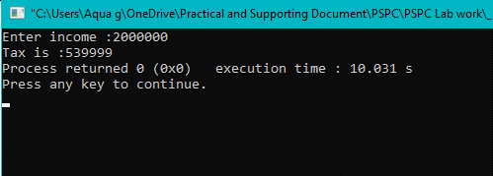

Experiment 24
Aim: Write a program to implement calculator using switch statement
Software used: CodeBlocks
Program:
#include <stdio.h>
#include <stdlib.h>
int main()
{
int a,b;
char op;
printf("Enter the two numbers\n");
scanf("%d %d",&a,&b);
printf("Enter the operation(+,-,*,/,%)\n");
scanf(" %c",&op);

switch(op)
{
case '+':
printf("Sum is %d",a+b);
break;
case '-':
printf("Difference is %d",a-b);
break;
case '*':
printf("Product is %d",a*b);
break;
case '/':
if(b=0)
printf("invalid operation denominator is 0");
else
printf("Quoitent is %d",a/b);
break;
case '%':
printf("Remainder is %d",a%b);
break;
default:
printf("other option selected");
}
return 0;
}

Output:
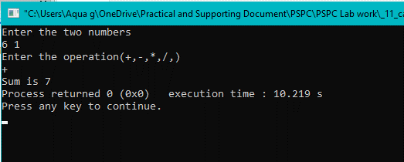

Experiment 25
Aim: Write a program to determine factorial of a number
Software used: CodeBlocks
Program:
#include <stdio.h>
#include <stdlib.h>
int main()
{
int num,fact=1;
printf("Enter the number ");
scanf("%d",&num);
if(num>=0)
{
for(int i=2;i<=num;i++)
{
fact=fact*i;
}
printf("factorial is %d",fact);
}
else
printf("Input is negative");
return 0;
}
Output:
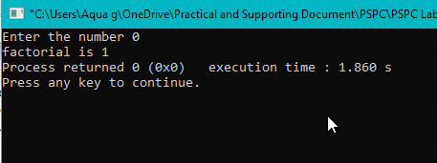

Experiment 26
Aim: Write a program to print the Fibonacci Series 0 1 1 2 3 5…… Input the number of terms from user.
Software used: CodeBlocks
Program:
#include <stdio.h>
#include <stdlib.h>
int main()
{
int nth;
printf("Enter term number ");
scanf("%d",&nth);
int prev=0,next=1,fib;
if(nth<=0)
printf("Invalid term entered");
else
{
if(nth==1)
fib=0;
else if(nth==2||nth==3)
fib=1;
else
for(int i=2;i<nth;i++)
{
fib=prev+next;
prev=next;
next=fib;
}

printf("%dth fibonacci term is %d",nth,fib);
}
return 0;
}
Output:
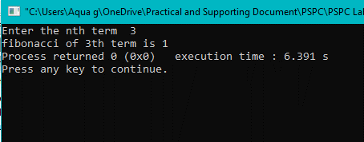

Experiment 27
Aim: Write a program to print the multiplication table in the following pattern
1 2 3 4 5 6 7 8 9 10
2 4 6 8 10 12 14 16 18 20 ……
10 20 30 40 50 60 70 80 90 100
Software used: CodeBlocks
Program:
#include <stdio.h>
#include <stdlib.h>
int main()
{
int k,l;
for(k=1;k<=10;k++)
{
for(l=1;l<=10;l++)
{
printf("%d\t",k*l);
}
printf("\n");
}

return 0;
}
Output:
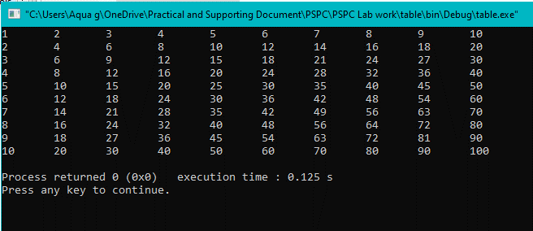
Experiment 28
Aim: Write a program to print the following patterns
- a
a b
a b c
a b c d
a b c d e
- * * * * *
* * * *
* * *
* *
*
Software used: CodeBlocks
Program:
i) #include <stdio.h>
#include <stdlib.h>
int main()
{
int i,j;
for(i=97;i<102;i++)
{
for(j=97;j<=i;j++)
printf("%c\t",j);
printf("\n");
}
return 0;
}
Output:
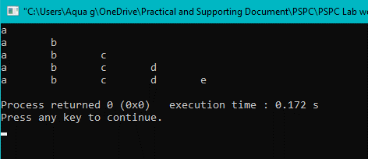

ii) #include <stdio.h>
#include <stdlib.h>
int main()
{
int m,n,space=0;
for(m=5;m>=1;m--)
{
for(n=1;n<=m;n++)
{
printf("*\t");
}
printf("\n");
space+=1; //incrementing space after each row
for(n=1;n<=space;n++) //printing spaces
{
printf("\t");
}
}
return 0;
}
Output:
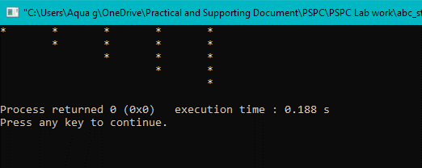

Experiment 29
Aim: Write a user defined function that takes year as parameter, and it prints whether the year is leap year or not.
Software used: CodeBlocks
Program:
#include <stdio.h>
#include <stdlib.h>
int main()
{
int year;
printf("Enter year ");
scanf("%d",&year);
if( (year%4==0&&year%100!=0) || (year%400==0))
printf("It is Leap year");
else
printf("Not a Leap Year");
return 0;
}
Output:
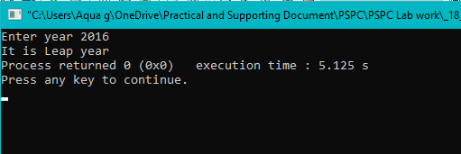

Experiment 30
Aim: Write a user defined function to print reverse of a number. The number should be passed as argument to the function and the function should return the reverse value.
Software used: CodeBlocks
Program:
#include <stdio.h>
#include <stdlib.h>
int rev(int num);
int main()
{
int num,ans;
printf("Enter the number: ");
scanf("%d",&num);
ans=rev(num);
printf("Reverse of the number: %d",ans);
return 0;
}
int rev(int num)
{
int res=0,power=1;
while(num!=0)
{
res=res*10+(num%10);
power=power*10;
num=num/10;
}
return res;
}

Output:
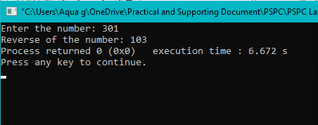

Experiment 31
Aim: Write a program to determine factorial of a number. (Using Recursion)
Software used: CodeBlocks
Program:
#include <stdio.h>
#include <stdlib.h>
int factorial(int n);
int main()
{
int fact,num;
printf("Enter the number ");
scanf("%d",&num);
fact=factorial(num);
printf("factorial is %d",fact);
return 0;
}
int factorial(int n)
{
int res;
if(n==0||n==1)
res=1;
else
res=n*factorial(n-1);
return res;
}

Output:
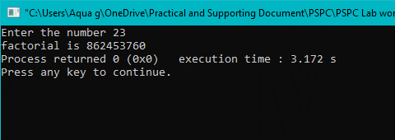

Experiment 32
Aim: Write a program to print the Fibonacci Series 0 1 1 2 3 5…… Input the number of terms from user. (using recursion)
Software used: CodeBlocks
Program:
#include <stdio.h>
#include <stdlib.h>
int factorial(int n);
int main()
{
int fib,num;
printf("Enter the nth term ");
scanf("%d",&num);
if(num<=0)
printf("Invalid term entered");
else
{
fib=fibonacci(num);
printf("fibonacci of %dth term is %d",num,fib);
}
return 0;
}
int fibonacci(int n)
{
int res;
if(n==1)
res=0;
else if(n==2||n==3)
res=1;
else
res=fibonacci(n-1)+fibonacci(n-2);
return res;
}
Output:
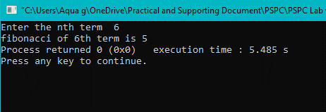

Experiment 33
Aim: Write a program to swap two numbers using call by value parameter passing mechanism.
Software used: CodeBlocks
Program:
#include <stdio.h>
#include <stdlib.h>
void swap(int a, int b);
int main()
{
int a,b;
printf("Enter two numbers ");
scanf("%d %d",a,b);
//call by value
swap(a,b);
return 0;
}
void swap(int x, int y)
{
x=x+y;
y=x-y;
x=x-y;
printf("swapped nos are: %d %d",x,y);
}
Output:
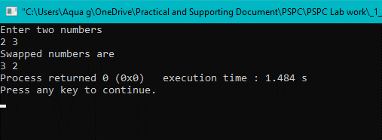
Experiment 34
Aim: Write a program to display the count of times the function is called.
Software used: CodeBlocks
Program:
#include <stdio.h>
#include <stdlib.h>
static int count=0;
void fun(int x);
int main()
{
int n;
printf("Enter the no. of times to call the function: ");
scanf("%d",&n);
for(int i=1;i<=n;i++)
{
fun(i);
}
printf("\n\nTotal no of times function called: %d",count);
return 0;

}
void fun(int x)
{
printf("function called %d time",x);
printf("\n");
count=count+1;
}

Output:
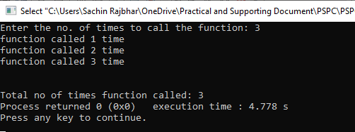

Experiment 35
Aim: Write a program to access a variable defined in other file using extern storage class.
Software used: CodeBlocks
Program:
(main.c)
#include <stdio.h>
#include <stdlib.h>
int main()
{
extern int a;
printf("calling function");
scextern();
a=10;
printf("\n%d",a);
scextern();
return 0;
}
(file1.c)
#include <stdio.h>
int a=8;
void scextern()
{
printf("\nValue of a is \n%d",a);
}
(file2.h)
void scextern();

Output:
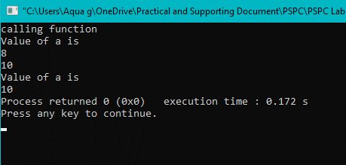

Experiment 36
Aim: Write a program to determine the largest element of 1-D array.
Software used: CodeBlocks
Program:
#include <stdio.h>
#include <stdlib.h>
int main()
{
int arr1[50],n,largest;
printf("Enter no. of elements in 1D array(1 to 50): ");
scanf("%d",&n);
printf("Enter elements in the 1D array(1 to %d): \n",n);
for(int i=0;i<n;i++)
scanf("%d",&arr1[i]);
largest=arr1[0];
for(int i=1;i<n;i++)
{
if(arr1[i]>largest)
largest=arr1[i];
}
printf("\nLargest no. in the array is: %d",largest);
return 0;
}
Output:
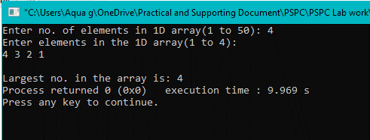
Experiment 37
Aim: Write a program to add and multiply two matrices. Use 2-D array. Take choice from user whether he want to add or multiply the matrices. Display the original matrices and the computed result.
Software used: CodeBlocks
Program:
#include <stdio.h>
#include <stdlib.h>
int main()
{
int arr1[2][2],arr2[2][2],ch,res[2][2];
printf("Enter the (2x2)matrix 1 elements: \n");
for(int i=0;i<2;i++)
{
for(int j=0;j<2;j++)
scanf("%d",&arr1[i][j]);
}
printf("Enter the (2x2)matrix 2 elements: \n");
for(int i=0;i<2;i++)
{
for(int j=0;j<2;j++)
scanf("%d",&arr2[i][j]);
}
printf("Enter the operation\n1 for Addition\n2 for Multiplication\n");
scanf("%d",&ch);
switch(ch)
{
case 1:
printf("Resultant Array(added) is: \n");
for(int i=0;i<2;i++)
{
for(int j=0;j<2;j++)
{
res[i][j]=arr1[i][j]+arr2[i][j];
printf("%d\t",res[i][j]);
}
printf("\n");
}
break;
case 2:
printf("Resultant Array(multiplication) is: \n");
for(int i=0;i<2;i++)
for(int j=0;j<2;j++)
{
res[i][j]=0;
for(int k=0;k<2;k++)
res[i][j]=res[i][j]+arr1[i][k]*arr2[k][j];
}
for(int i=0;i<2;i++)
{
for(int j=0;j<2;j++)
printf("%d\t",res[i][j]);
printf("\n");
}

break;
default: printf("Invalid operation number entered");
}
return 0;
}

Output:
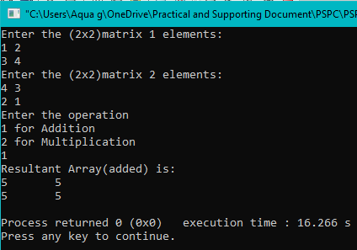

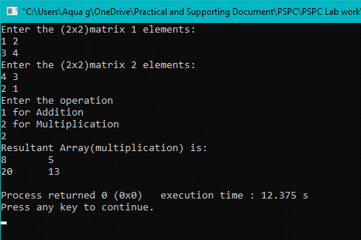

Experiment 38
Aim: Write a program to transpose a matrix. Use 2-D array. Display the original matrix and transposed result.
Software used: CodeBlocks
Program:
#include <stdio.h>
#include <stdlib.h>
int main()
{
int arr[3][3],transpose[3][3];
printf("Enter (3x3)matrix elements: \n");
for(int i=0;i<3;i++)
{
for(int j=0;j<3;j++)
scanf("%d",&arr[i][j]);
}
// display original array
printf("Original array: \n");
for(int i=0;i<3;i++)
{
for(int j=0;j<3;j++)
{
printf("%d\t",arr[i][j]);
}
printf("\n");
}
// taking transpose & displaying it
printf("Transposed array: \n");
for(int i=0;i<3;i++)
{
for(int j=0;j<3;j++)
{
transpose[i][j]=arr[j][i];
printf("%d\t",transpose[i][j]);
}
printf("\n");
}
return 0;
}
Output:
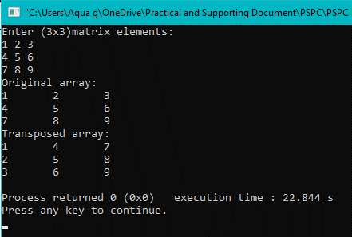

Experiment 39
Aim: Write a C program to display the count of vowels and consonants in a string input by user.
Software used: CodeBlocks
Program:
#include <stdio.h>
#include <ctype.h>
#include <string.h>
int main()
{
char a[100],vowel=0,conso=0,x;
printf("Enter a string(max 100 length)\n");
gets(a);
for(int i=0;a[i]!='\0';i++)
{
x=toupper(a[i]);
if(x=='A'||x=='E'||x=='I'||x=='O'||x=='U')
++vowel;
else if((a[i]>='a'||a[i]>='A')&&(a[i]<='z'||a[i]<='Z'))
++conso;
}
printf("No. of Vowels= %d & Consonants= %d",vowel,conso);
return 0;
}
Output:
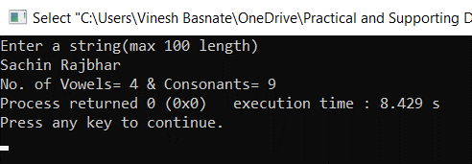
Experiment 40
Aim: Write a C program to concatenate first name and last name input by user without using string.h built in functions.
Software used: CodeBlocks
Program:
#include <stdio.h>
#include <ctype.h>
#include <string.h>
int main()
{
char fname[20],lname[20],res[40];
printf("Enter First Name\n");
gets(fname);
printf("Enter First Name\n");
gets(lname);
printf("Concatenated String is\n%s",strcat(strcat(fname," "),lname));
return 0;
}
Output:
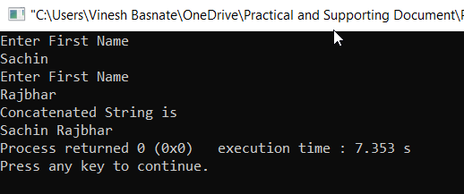

Experiment 41
Aim: Write a C program using pointers to evaluate the arithmetic expression z = 5* - *p2/ *p1.
Software used: CodeBlocks
Program:
#include <stdio.h>
#include <stdlib.h>
int main()
{
int a=1,b=2,*p1,*p2,z;
p1=&a;
p2=&b;
z=5*-*p2/ *p1;
printf("Value of expression z=5*-*p2/ *p1: %d\n",z);
return 0;
}
Output:
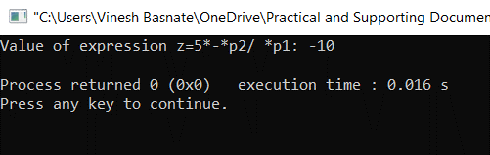

Experiment 42
Aim: Write a C program to illustrate the concept of Call by reference.
Software used: CodeBlocks
Program:
#include <stdio.h>
#include <stdlib.h>
//call by refrence
int add(int *a,int *b);
int main()
{
int a,b,s;
printf("Enter two numbers ");
scanf("%d %d",&a,&b);
s=add(&a,&b);
printf("Sum is %d",s);
return 0;
}
int add(int *a,int *b)
{
int sum;
sum=*a+*b;
return sum;
}
Output:
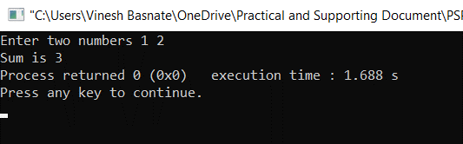
Experiment 43
Aim: Write a C program to determine sum of all elements of one-dimensional array using
pointers.
Software used: CodeBlocks
Program:
#include<stdio.h>
int main()
{
int i,sum=0;
int a[]={600,500,10,400,50,21};
int *ptr;
ptr=a;
for(i=0;i<6;i++){
sum=sum + *ptr;
ptr++;
}
printf("sum is:%d",sum);
return 0;
}
Output:
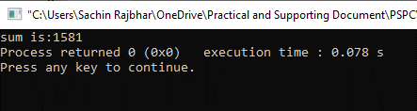

Experiment 44
Aim: Write a C program to determine average of all elements of two-dimensional array using
pointers.
Software used: CodeBlocks
Program:
#include<stdio.h>
int main()
{
int numbers[100][100];
int rows,columns;
float average;
int sum =0;
int (*ptr)[100][100];
ptr = &numbers;
printf("Enter the number of rows:\n");
scanf("%d",&rows);
printf("Enter the number of columns:\n");
scanf("%d",&columns);
printf("Enter the Input elements:\n");
for(int i=0;i<rows;i++)
{
for(int j=0;j<columns;j++)
{
scanf("%d",&(*ptr)[i][j]);
}
}
for(int i=0;i<rows;i++)
{
for(int j=0;j<columns;j++)
{
sum = sum + ((*ptr)[i][j]);
}
}
average = sum/(float)(rows*columns);
printf("The average is:%f",average);
return 0;
}
Output:
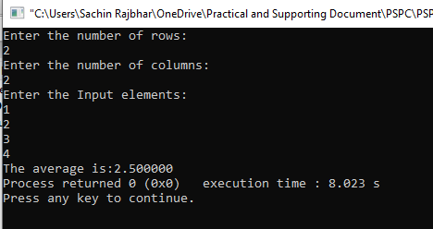

Experiment 45
Aim: Write a C program to calculate return the address of ith element of array using the
concept of function returning pointers.
Software used: CodeBlocks
Program:
#include<stdio.h>
#include<math.h>
int*returnaddress (int a[],int n);
main()
{
int a[]={1,2,3,4,5,6},i;
printf("Enter ith number ");
scanf("%d",&i);
int*ptr = returnaddress (a,i);
printf("base address= %d\n",a); //base address(address of 0th element)
printf("address value of ith element= %d",ptr); //address of ith element
return 0;
}
int*returnaddress(int a[],int n)
{
int*p;
p=a;
p=p+n;
return p;
}
Output:
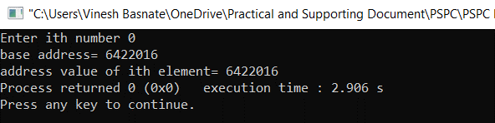
Experiment 46
Aim: Write a C program to print a table of values of expressions 1) x²-x+1 2) sin using function pointer
Software used: CodeBlocks
Program:
#include <stdio.h>
#include <stdlib.h>
#include <math.h>

double table (double(*fptr)(double a),double min,double max,double step);
double y(double x);

double flag=0;

void main()
{
double result;
result=table(y,0,2,0.5);
printf("\nFinal value of x^2-x+1 is %f",result);
printf("\n\n");
result=table(sin,0,M_PI,0.5);
printf("\nFinal value of sin is %f",result);
}
double y(double x)
{
return (x*x-x+1);
}
double table (double(*fptr)(double a),double min,double max,double step)
{
double value;
for(double i=min;i<=max;i+=step)
{
value=(*fptr)(i);
if(flag==0)
printf("Value of x^2-x+1 at %f is %f\n",i,value);
else
printf("Value of sin at %f is %f\n",i,value);
}
flag=1;
return value;
}
Output:
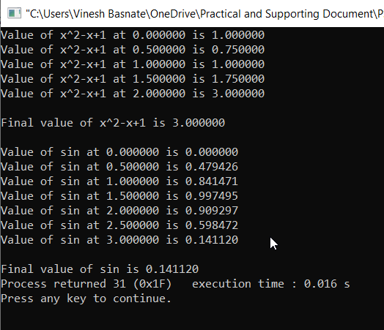

Experiment 47
Aim: Write a C program to dynamically allocate size for array using malloc/calloc. Read the
array elements from user. Reallocate the size using realloc. Deallocate the memory allocated
using free.
Software used: CodeBlocks
Program:
#include <stdio.h>
#include <stdlib.h>
int main()
{
int n,*ptr;
printf("Enter the size of 1D-array needed ");
scanf("%d",&n);
ptr=(int*)calloc(n,sizeof(int));
//allocated or not
if(ptr==NULL)
{
printf("\nMemory Not allocated");
exit(0);
}
else
{
printf("\nMemory successfully allocated using calloc");
printf("\nEnter the elements\n");
for(int i=0;i<n;++i)
scanf("%d",ptr+i);
printf("Elements are\n");
for(int i=0;i<n;++i)
printf("%d ",*(ptr+i));
}
printf("\n\nEnter the new size of array ");
scanf("%d",&n);
ptr=(int*)realloc(ptr,n*sizeof(int));
//reallocated or not
if(ptr==NULL)
{
printf("\nMemory Not allocated");
free(ptr);
printf("\nMemory Deallocated using free");
exit(0);
}
else
{
printf("\nMemory successfully allocated using realloc");
printf("\nEnter the elements\n");
for(int i=0;i<n;++i)
scanf("%d",ptr+i);
printf("Elements are\n");
for(int i=0;i<n;++i)
printf("%d ",*(ptr+i));
free(ptr);
printf("\nMemory Deaalocated using free");
}
return 0;
}

Output:
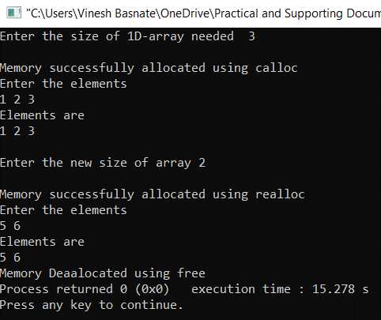

Experiment 48
Aim: Write a program to calculate AREA of a square using macro with arguments.
Software used: CodeBlocks
Program:
#include <stdio.h>
#include <stdlib.h>

#define AREA(X) X*X
int main()
{
printf("Value of AREA Macro at 10 is %d",AREA(10));
return 0;
}
Output:
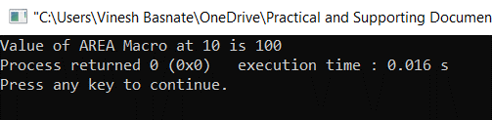

Experiment 49
Aim: Write a program to demonstrate compiler control directives for conditional compilation.
Software used: CodeBlocks
Program:
#include <stdio.h>
#include <stdlib.h>

#define TEST 10
int main()
{
#if(TEST<=5)
printf("I am less than or equal to 5\n");
printf("Existing less than equal to 5");
#elif(TEST>5&&TEST<=8)
printf("I am 5 to 8\n");
printf("Existing 5 to 8");
#else
printf("I am else\n");
printf("Existing else");
#endif
}
Output:
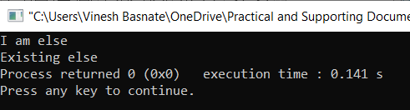

Experiment 50
Aim: Write a program to demonstrate pointer to structures.
Software used: CodeBlocks
Program:
#include <stdio.h>
#include <stdlib.h>
struct inventory
{
char name[20];
int credits;
char section;
int rollno;
}s1,*ptr;
int main()
{
ptr=&s1;
printf("Enter name,credits,section,rollno\n");
scanf("%s %d %c %d",ptr->name,&ptr->credits,&ptr->section,&ptr->rollno);
printf("\nEntered details are\n");
printf("%s %d %c %d",ptr->name,ptr->credits,ptr->section,ptr->rollno);
return 0;
}
Output:
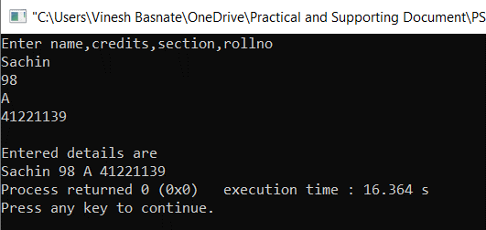
Experiment 51
Aim: Write a program to pass structures to functions.
Software used: CodeBlocks
Program:
#include <stdio.h>
struct stores
{
char name[20];
float price;
int quantity;
};
struct stores update(struct stores item, float p, int q);
int main()
{
float price_increment;
int quantity_increment;
struct stores item = {"Pen", 12.50, 50};
printf("Enter price and quantity incremenets\n");
scanf("%f %d", &price_increment, &quantity_increment);
item = update(item, price_increment, quantity_increment);
printf("Updated Price Details\n");
printf("%s\n", item.name);
printf("%f\n", item.price);
printf("%d\n", item.quantity);

return 0;
}
struct stores update(struct stores item, float p, int q)
{
item.price += p;
item.quantity += q;
return item;
}
Output:
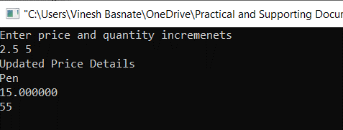

Experiment 52
Aim: Write a program to pass pointer to structures to functions.
Software used: CodeBlocks
Program:
#include <stdio.h>
struct stores{
char name[20];
float price;
int quantity;
};

void update(struct stores* item, float p, int q);
int main(){
float price_increment;
int quantity_increment;
struct stores item = {"Pen", 12.50, 50};
printf("Enter price and quantity incremenets\n");
scanf("%f %d", &price_increment, &quantity_increment);
update(&item, price_increment, quantity_increment);
printf("Updated Price Details\n");
printf("%s\n",item.name);
printf("%f\n",item.price);
printf("%d\n",item.quantity);

return 0;
}
void update(struct stores* item, float p, int q){
item->price += p;
item->quantity += q;
}
Output:
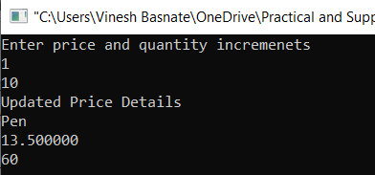

Experiment 53
Aim: Create an enumeration weekday with enumerators as Sun, Mon, Tue, Wed, Thurs, Fri,
Sat. Print the integral value for Thursday.
Software used: CodeBlocks
Program:
#include <stdio.h>
enum weekday{sun, mon, tue, wed, thu, fri, sat};
int main(){
enum weekday w1;
w1 = thu;
printf("%d", w1);
return 0;
}

Output:
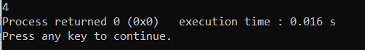

Experiment 54
Aim: Write a program to
a) Open the file
b) Read the file & write to file
c) Close the file
Software used: CodeBlocks
Program:
#include <stdio.h>
#include <stdlib.h>
int main()
{
FILE *f1;
char c;
f1 = fopen("newfile.txt", "r");
if (f1 == NULL)
{
puts("Cannot Open File");
exit(1);
}

while (1)
{
c = getc(f1);
if (c == EOF)
{
break;
}
printf("%c", c);
}
fclose(f1);

f1 = fopen("newfile.txt", "w");
if (f1 == NULL)
{
puts("Cannot Open the file for writing");
exit(1);
}

else
{
while (c = getchar() != EOF)
{
putc(c, f1);
}
}
fclose(f1);
return 0;
}
Output:
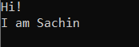

Experiment 55
Aim: Write a program to read the structure elements, write them to the file and read them back
using fread() and fwrite() functions. Modify the complete record for a given rollNo. The file
should be opened in binary mode.
Software used: CodeBlocks
Program:
#include <stdio.h>
#include <stdlib.h>
struct stud
{
char name[20];
int rollno;
float marks[5];
};
int main()
{
struct stud s1;
int rollno_mod,found=0;
FILE *fp;
fp=fopen("TESTF2.txt", "w+");
if(fp==NULL)
{
printf("Cannot Open\n");
exit(1);
}
else
for(int i =0;i<2;i++)
{
printf("Enter Name: ");
fflush(stdin);
gets(s1.name);
printf("Roll No.: ");
scanf("%d", &s1.rollno);
printf("Enter 5 Marks: \n");
for(int j=0;j<5;j++)
{
scanf("%f", &s1.marks[j]);
}
fwrite(&s1,sizeof(s1),1,fp);
}
rewind(fp);
printf("\nSTOREDRECORDS ARE:-\n\n");
while(fread(&s1,sizeof(s1),1,fp)>0)
{
printf("NAME: %s" "\n" "ROLL NO:%d\n", s1.name, s1.rollno);
for(int i=0;i<5;i++)
{
printf("%f", s1.marks[i]);
printf("\n");
}
}
printf("Enter the rollno to be modified");
scanf("%d",&rollno_mod);
rewind(fp);
while(fread(&s1,sizeof(s1),1,fp)>0)
{
if(s1.rollno==rollno_mod)
{
found=1;
break;
}
}
if(found==1)
{
fseek(fp,-sizeof(s1),SEEK_CUR);
printf("Enter new record\n");
printf("Enter Name: ");
fflush(stdin);
gets(s1.name);
printf("Roll No.: ");
scanf("%d", &s1.rollno);
printf("Enter 5 Marks: \n");
for(int j=0;j<5;j++)
{
scanf("%f", &s1.marks[j]);
}
fwrite(&s1,sizeof(s1),1,fp);
}
rewind(fp);
printf("\nSTOREDRECORDS ARE:-\n\n");
while(fread(&s1,sizeof(s1),1,fp)>0)
{
printf("NAME: %s" "\n" "ROLL NO:%d\n", s1.name, s1.rollno);
for(int i=0;i<5;i++)
{
printf("%f", s1.marks[i]);
printf("\n");
}
}
fclose(fp);
return 0;
}
Output:
